Adding donor philanthropic interests

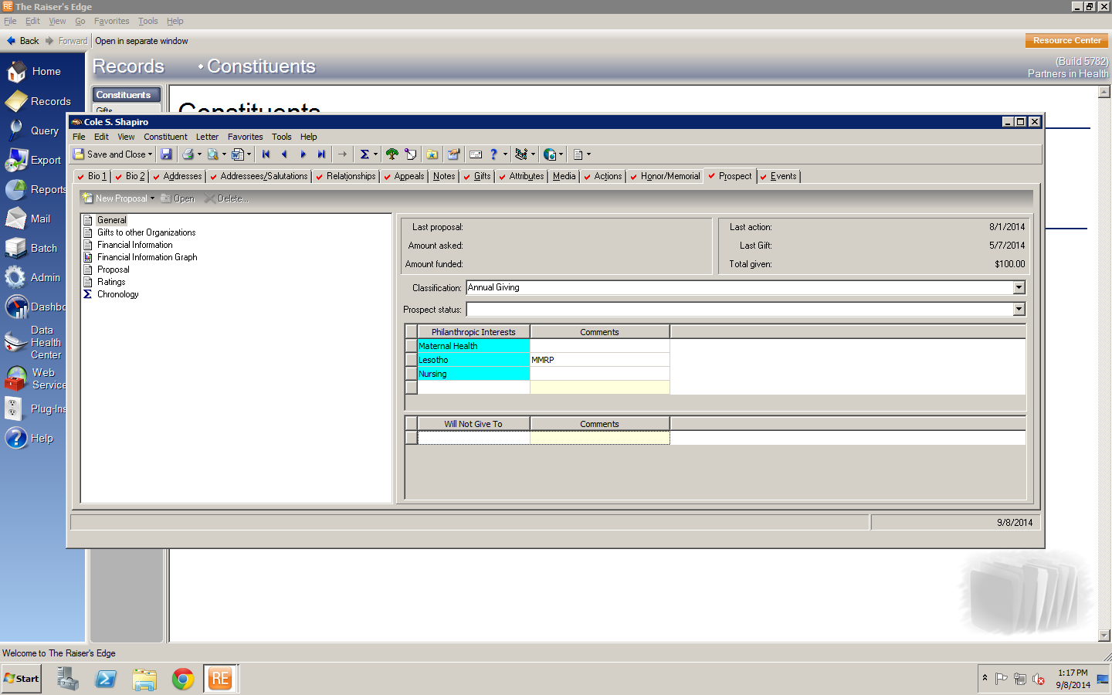

Searching for submitted proposals

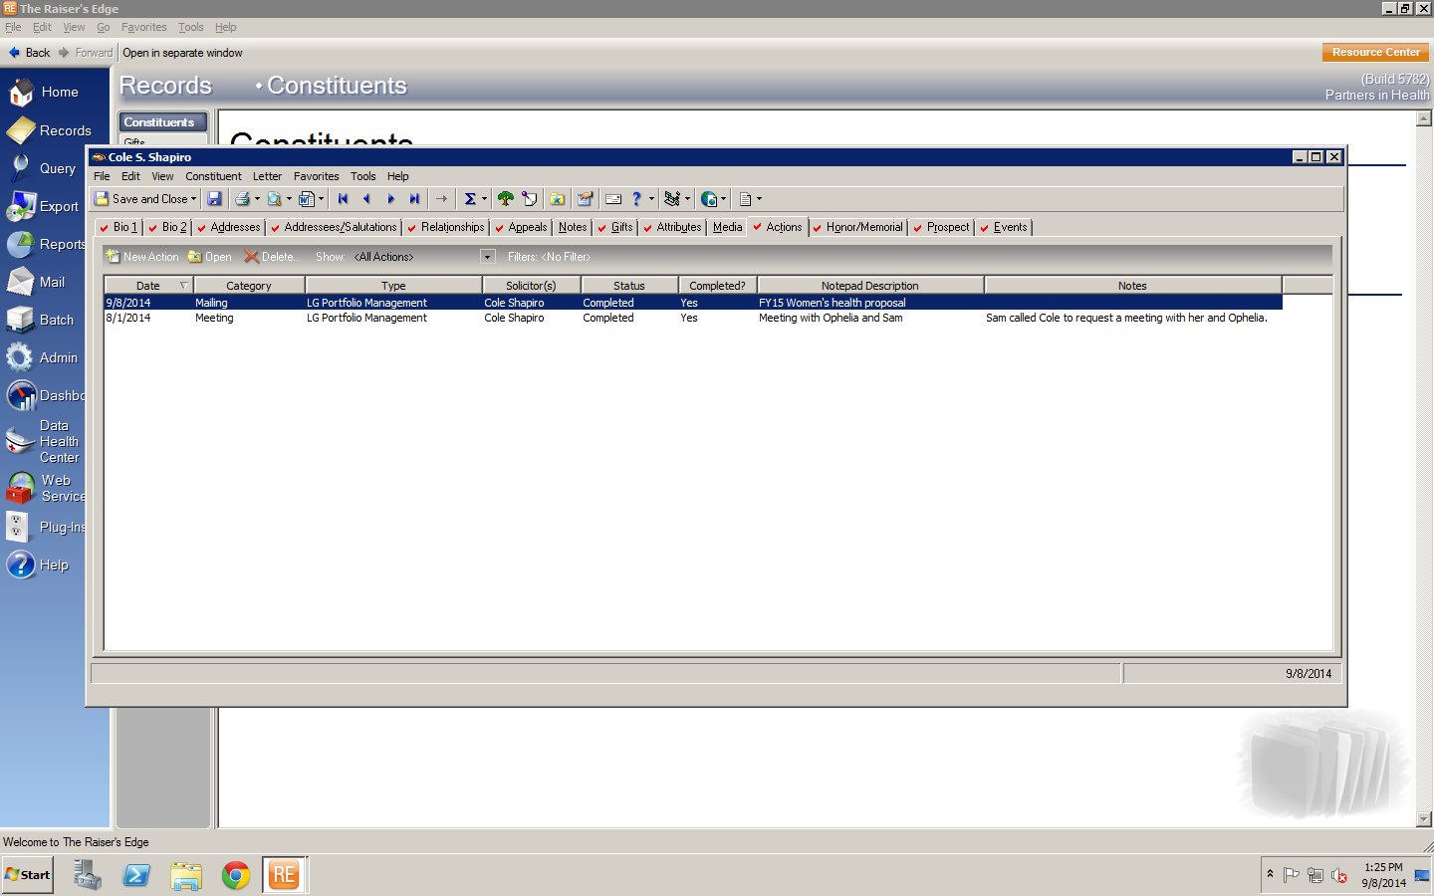

Proposal under Actions

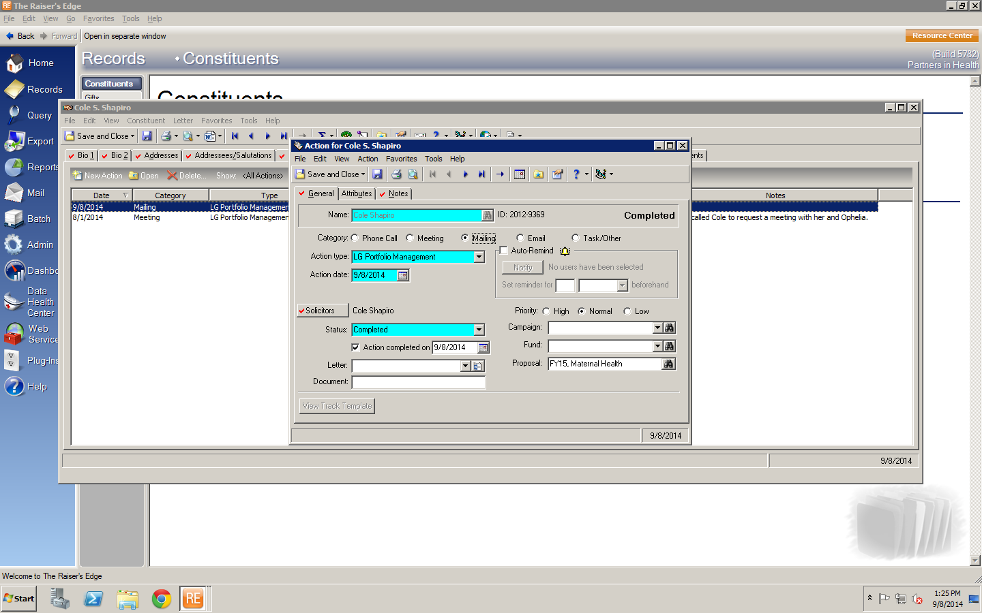

Proposal under Actions (linked to Proposal in Prospect Tab)

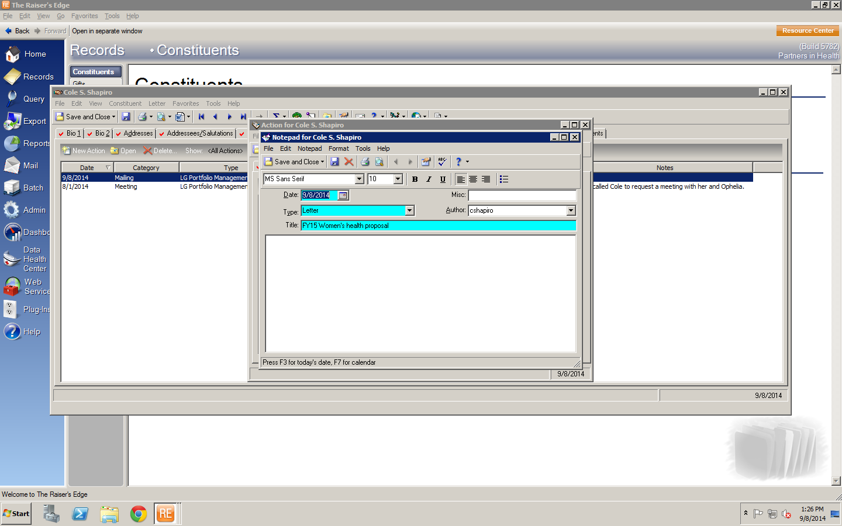

Proposal under Actions

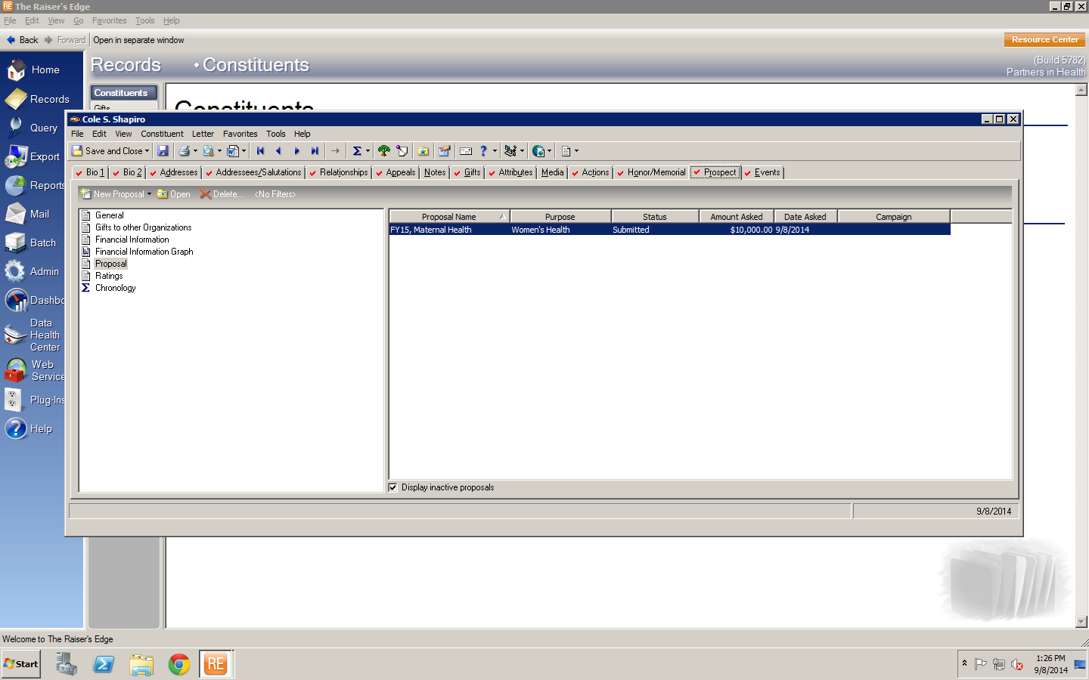

Proposal under Prospect Tab

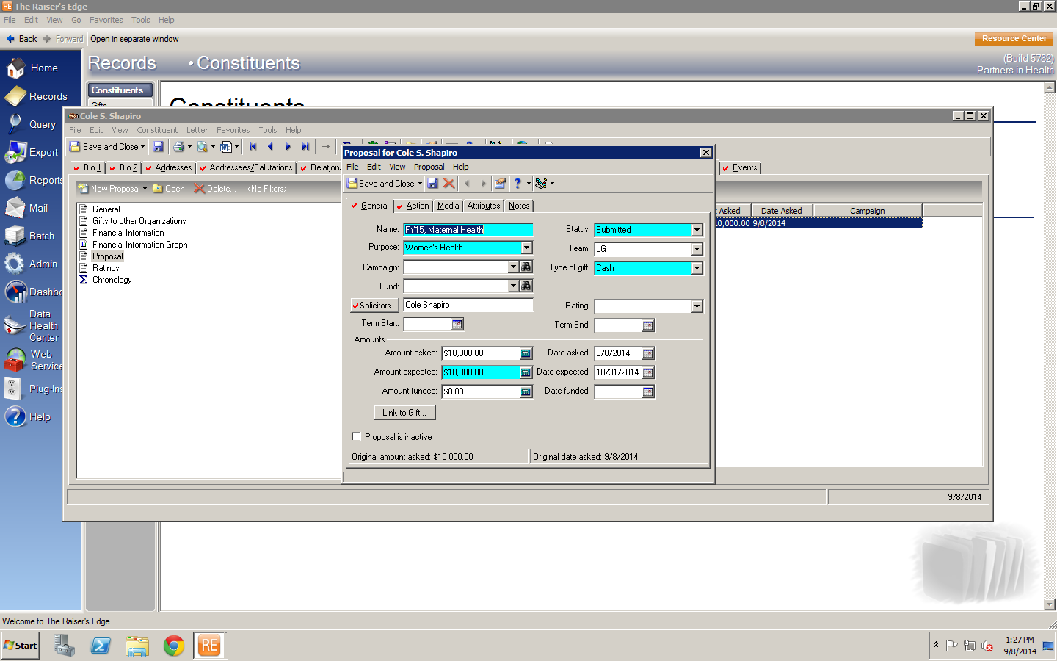

Proposal under Prospect Tab

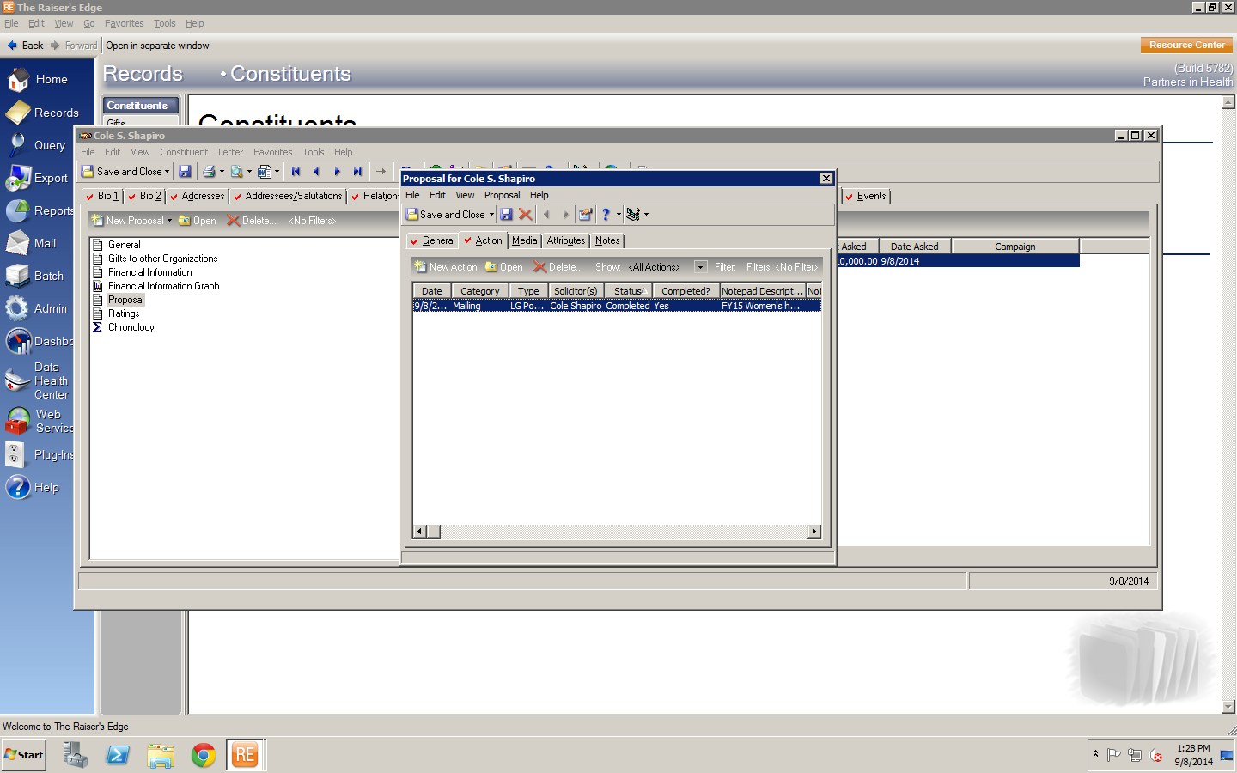

Proposal in Prospect Tab (linked to Action)

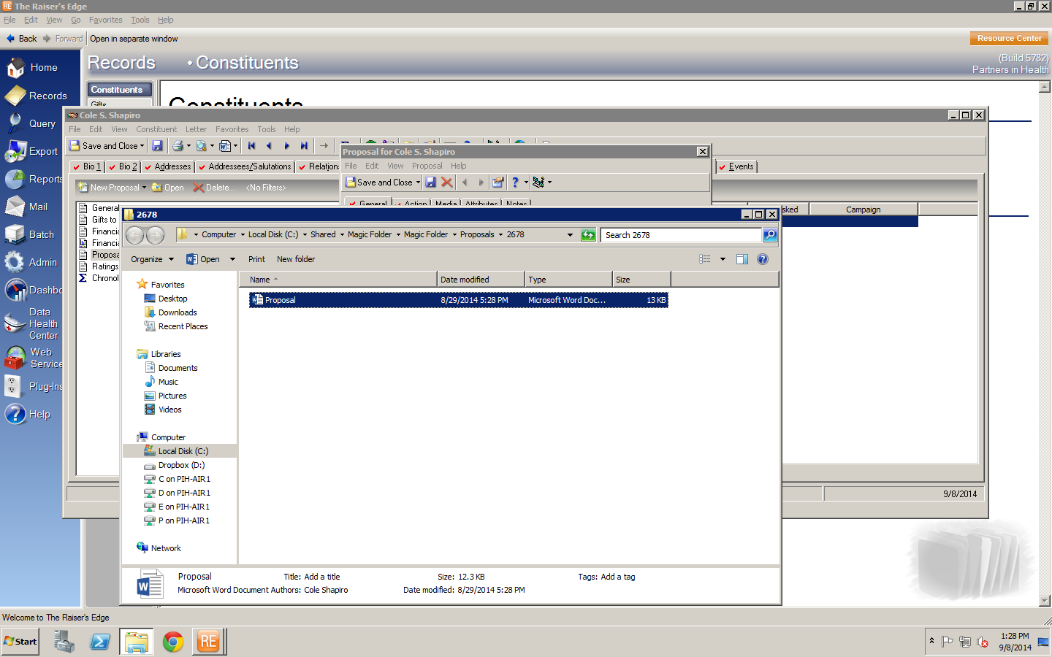

Proposal located in Magic Folder

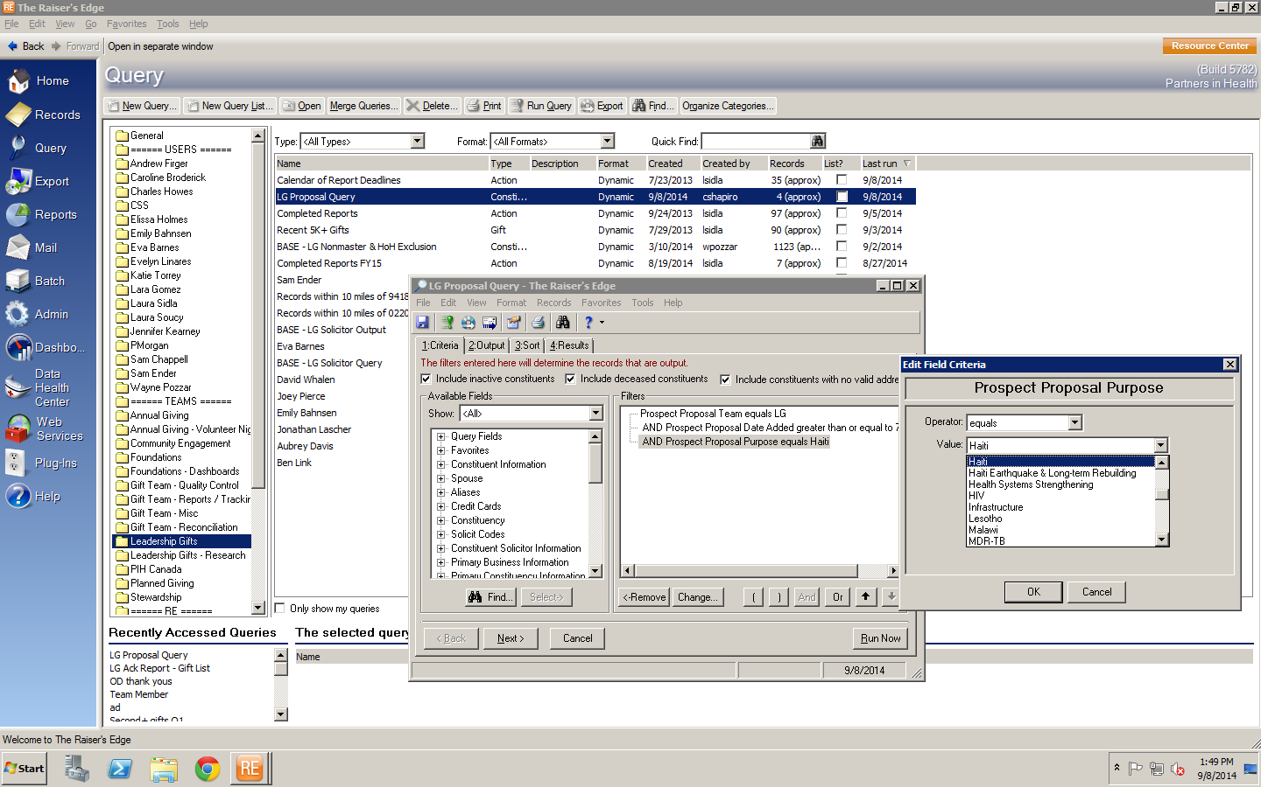

LG Proposal Query located in Query: Leadership Gifts: “LG Proposal Query”

Choose the Proposal Purpose from dropdown, then click “Run Now”

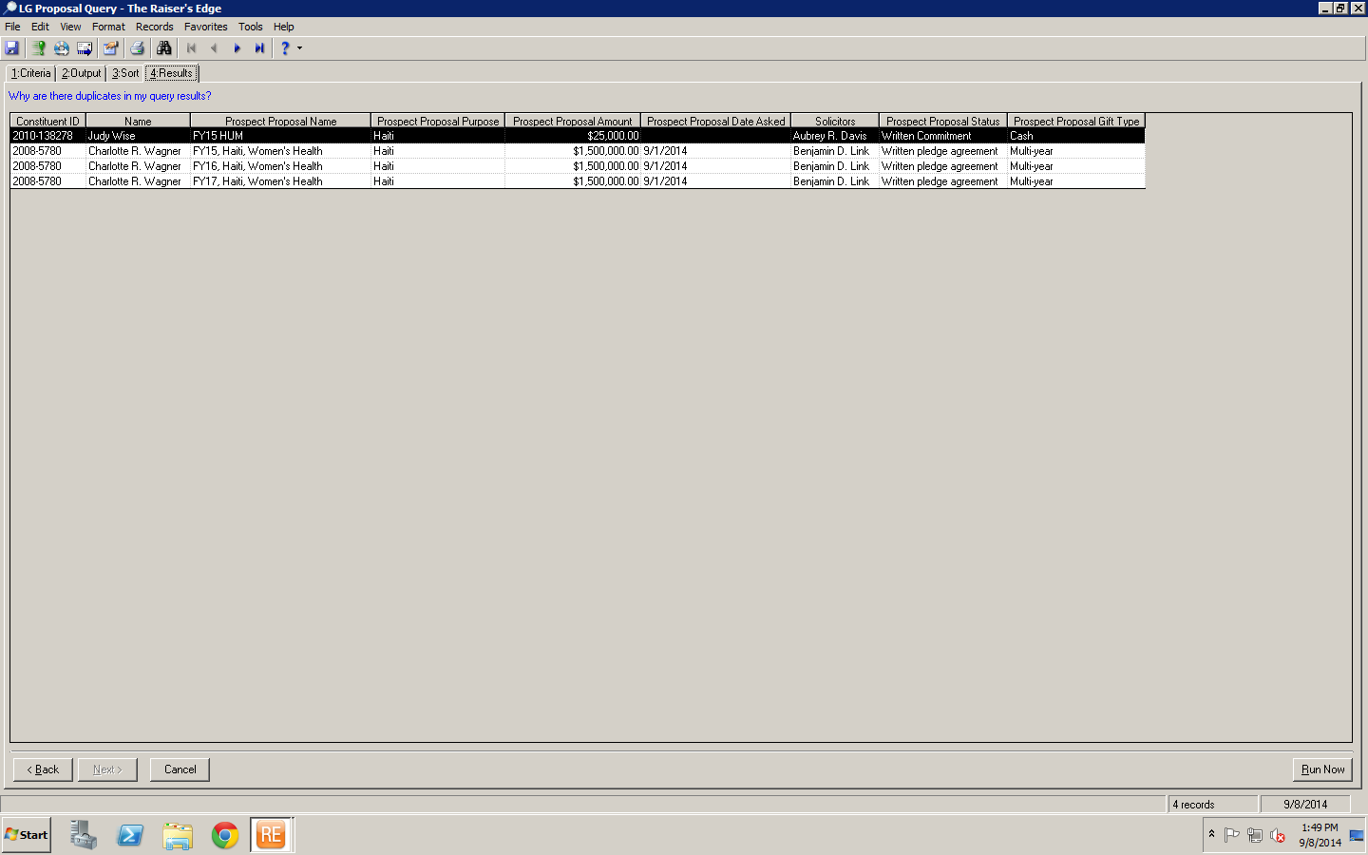

Locate the material you want to see